E-commerce Web Shop Solution

1st Custom Software Development, Inc.
3241 Hidden Cove Circle
Norcross, GA 30092
Telephone: 404-993-2032

We are offering a high quality, affordable and modular e-commerce solution to power your web site storefront. As soon as in one week you can have your own web shop customized and deployed. We offer to custom tailor high quality open source e-commerce solution to run your business. The only requirement is that your web hosting service has to support PHP and MySql. Majority of them do.

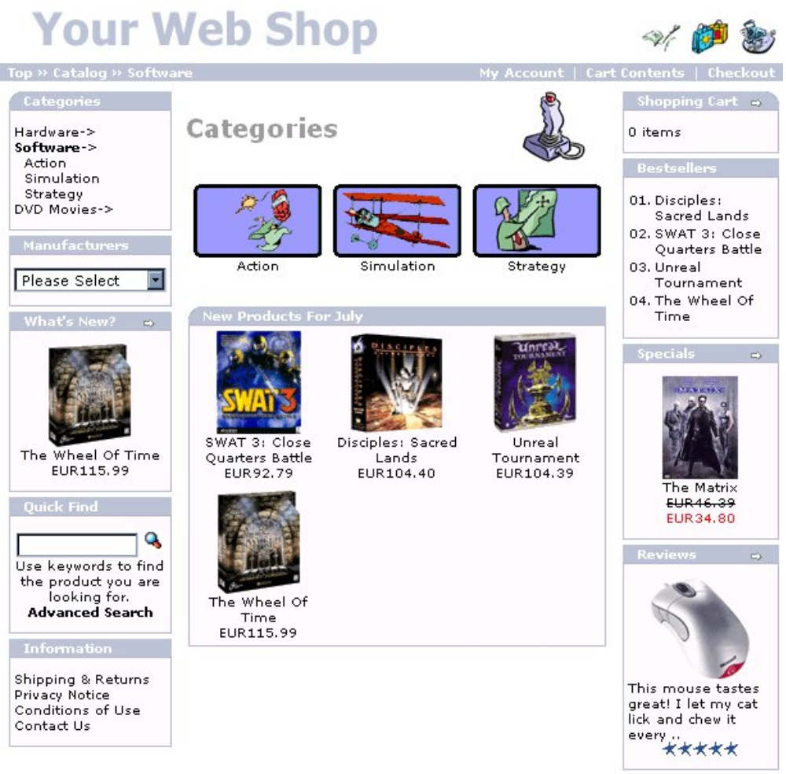
Picture 1
Store front sample
CHOOSE FUNCTIONALITY
We offer a modular design where you have the power to choose. You decide which modules you want and where to place them. Let’s say you sell the goods of your own manufacture so manufacturers module will not be shown. It is that simple, you have the power to decide.

LOOK AND FEEL
We place no limits on your web shop design. Ladybugs and daisies appeal to your gardening goods customers? No problem. We can design the look that feels just right for the customer. It just may be that all the features and outstanding design may set you apart from competition!
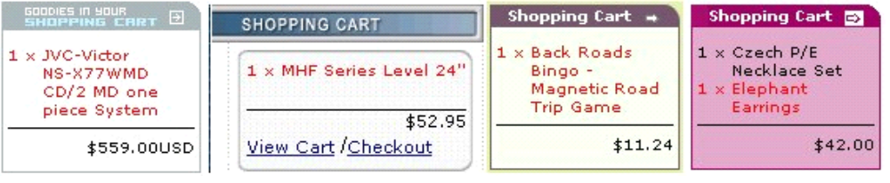
Picture 2
Couple examples of different design possibilities

SOME OF THE FUNCTIONALITY MODULES:
- Customer accounts
- Customer address books with multiple shipping destinations
- Order history
- Temporary (not logged on) and permanent (logged on) shopping carts
- Search catalog for products or manufacturers
- Product reviews by customers
- E-mail notifications - newsletters and order status
- Secure transactions with SSL
- Number of products in each category are shown
- Bestseller lists
- Display what other customers have purchased

This feature rich functionality gives the customer total control over shopping experience and confidence in shopping on your site. Every web storefront should have a polished professional look. With number of fraud cases rising the “feel” of the e-commerce establishment plays a big role in how trusty customers are to provide their credit card as means of payment. Do not turn away potential customers with amateur looking web shop!
Our solution also includes feature rich storefront administration side. We provide this administration functionality:
- Add/Edit/Remove categories, products, manufacturers, customers, and reviews
- Statistics for products and customers
- Dynamic product attributes
- Tax zones, classes, and rates
- Payment and shipping modules
- Connection to currency exchange rate servers for multi-currency shops
- Decide what to display (and the order) in the product listings
- Backup tool

These features make everyday task of upkeep easy and efficient, leaving more time to focus on your business not on your web store maintenance.
Other great benefit of our modular prepackaged solutions is a wide variety of payment/credit card authorizations gateways and multiple shipping options. You can select to use one of these feature payment gateways:
- authorizenet.com
- paypal.com
- psigate.com
- secpay.com
- 2checkout.com
- trustcommerce.com
- and many more

Shipping options is one of the most often overlooked features on e-commerce solutions. We include a wide selection of shipping options that can be turned on or off by administration tools. Some of the shipping options are:
- United States Postal Service
- UPS
- FedEx
- Shipping price per item
- and many more

Not only this “mini Amazon” solution is packed with features for your potential shopper, it automates a lot of order processing tasks: notifies customers about their order status changes, generates packing slips, invoices and many more.
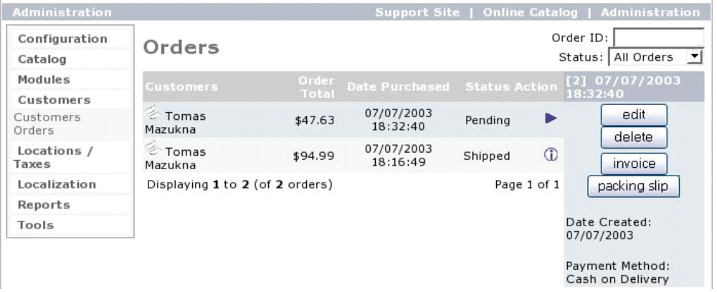
Picture 3
Orders administration screen

All these features can be turned on/off. Store configuration features provide a wide variety of options to customize this solution to effectively run your online business.
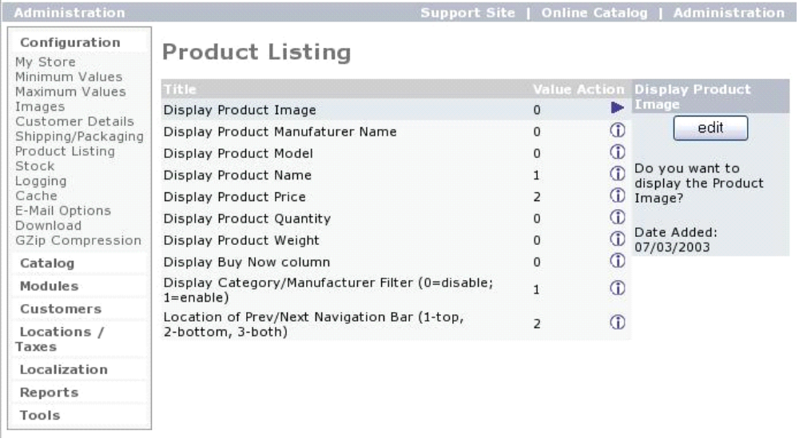
Picture 4
Product listing customization options
Your online store can have multiple/nested product categories and multiple manufactures, special (sale) items, upcoming products and even user written product reviews.
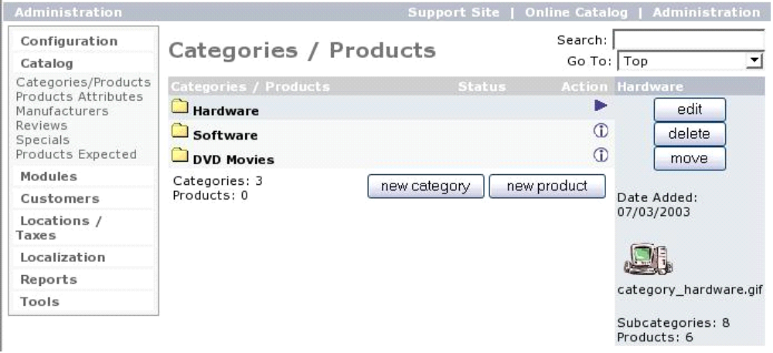
Picture 5
Administering products and categories

Depending on location and products you sell you may need multiple tax classes, zones and rates. We have a flexible solution to automatically include taxes when they are needed.
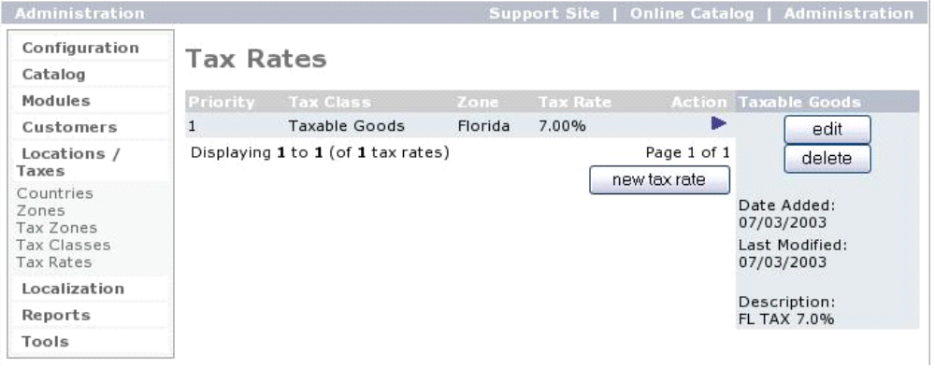
Picture 6
Tax option and location management

This solution has been in the production for over 4 years in number of business. The number is well over a 1000. This means that all errors and bugs are caught and this ecommerce web store solution is bullet proof. Your time will not be wasted. We would be glad to show you more!

